For Part 2 I wasn’t quite sure how to go about it, so I gave 2 solutions. Spaceballs is the movie they will be playing.

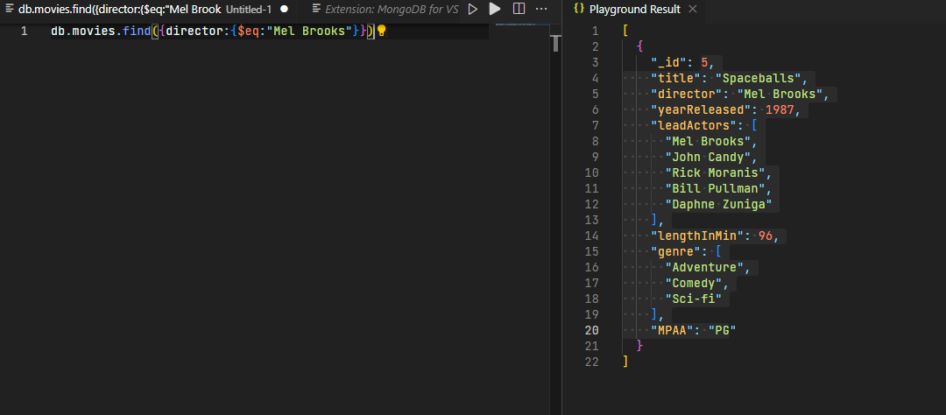

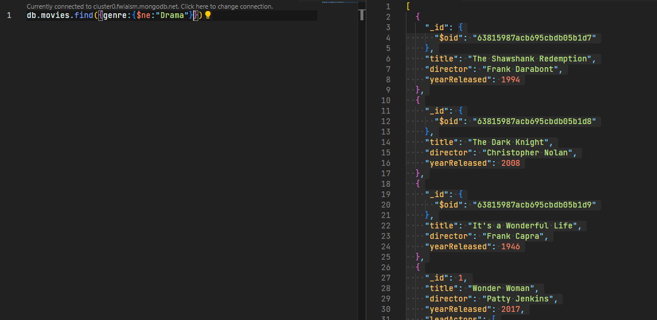

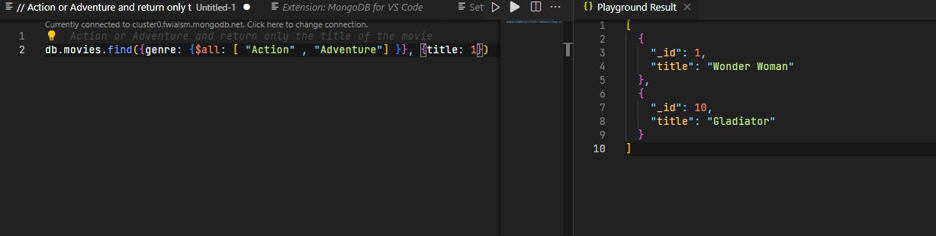

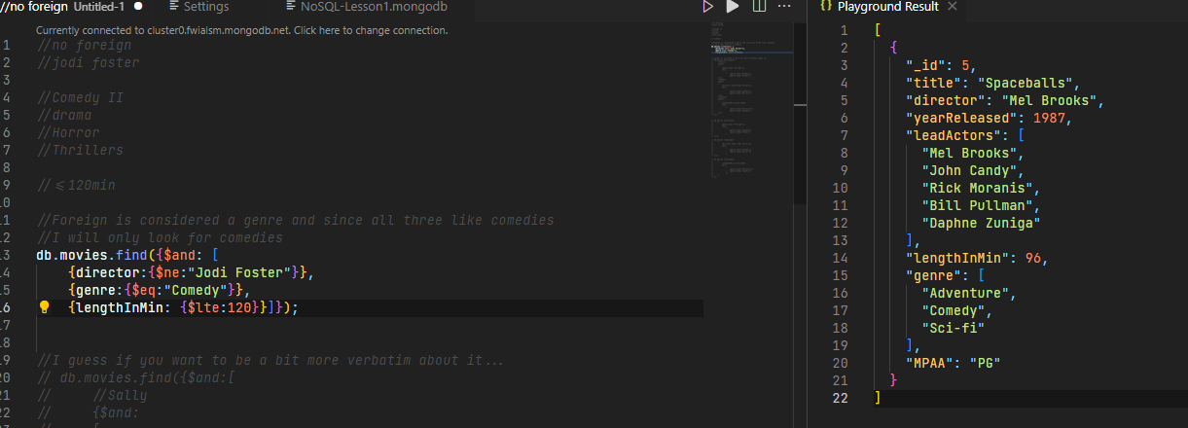

And if you only want the title.